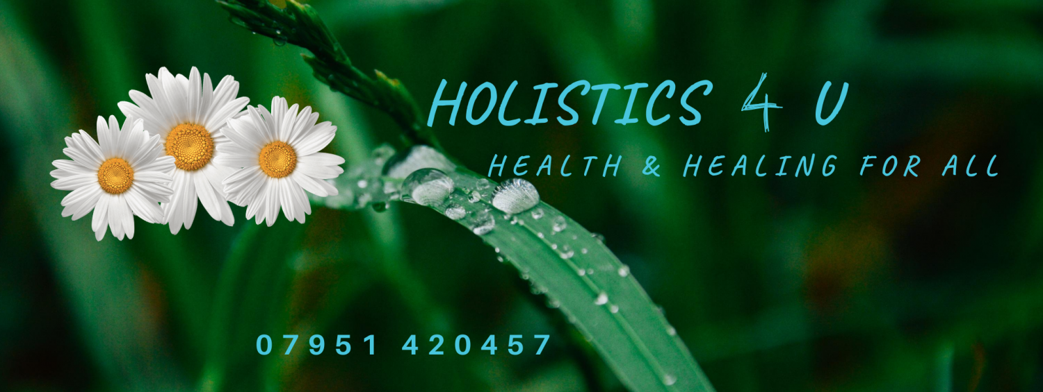

Teaching Academy

Courses

Massage
Advanced and Deep Tissue Massage - Diploma
Beauty facials - Diploma
Indian Head Massage - Diploma
Hot & Cold Stone Therapy - Diploma
Manual Lymphatic Drainage Massage – Diploma
Myofascial Release - Diploma
Natural Lift Facial/Face Rejuvenation - Diploma
Pregnancy Massage-Abdominal and Full Body – Diploma
Warm Bamboo Massage - Diploma

Wellbeing
Spa Body Wraps, Brushing, Exfoliation & Mask - Diploma
Meditation Tuition – Teachers Diploma
Crystal Healing & Chakra Balancing - Diploma
Aromatherapy Blending– Diploma

Other
Beginners Tarot Workshop, Spirit Guides & Lightbody Activation
Hopi Ear Candling/Thermo Auricular - Diploma
Kinesio taping KT1 & KT2 - Diploma
Spray Tanning Treatments – Diploma.

