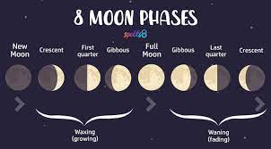
Growing Fading
New Moon Full Moon
2021 2021
Oct 6th Oct 20th – Hunters Moon
Nov 4th Nov 19th – Beavers Moon
Dec 4th Dec 19th – Cold Moon
2022 2022
Jan 2nd Jan 17th – Wolf Moon
Feb 1st Feb 16th – Snow Moon
Mar 2nd Mar 18th – Worm Moon
Apr 1st & 30th Apr 16th – Pink Moon
May 30th May 16th – Flower Moon
Jun 29th Jun 14th – Strawberry Moon
Jul 28th Jul 13th – Buck Moon
Aug 27th Aug 12th – Sturgeon Moon
Sep 25th Sep 10th – Corn Harvest Moon
Oct 25th Oct 9th – Hunters Moon
Nov 23rd Nov 8th – Beaver Moon
Dec 23rd Dec 8th – Cold Moon

